**NAME : AJAY K**

**ROLL NO : CH.EN.U4CCE22003**

**Single Inheritance**

**Program:**

**Output:**

**Multilevel Inheritance**

**Program:**

**Output:**

**Hierarchical Inheritance**

**Program:**

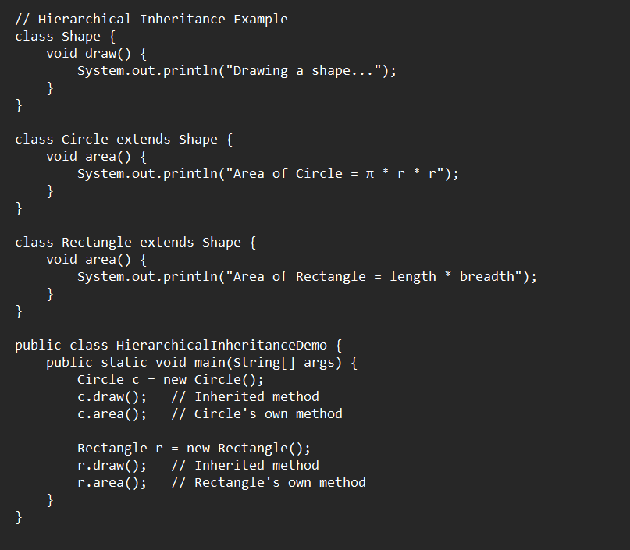

**Output:**

